**FAT MAN Float**

**Our Fat Man float** is inspired by the NSF-funded GO-BGC Project, which aims to build a global network of profiling floats to monitor ocean health. Similarly, our float is designed to perform multiple vertical profiles, diving from the surface to a depth of 2.5 meters, then returning to the surface. It records and transmits data, simulating real-world environmental monitoring devices.

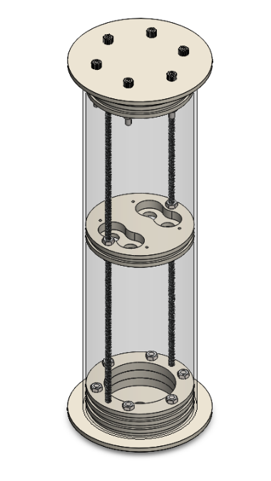

Figure 1: Illustrates the float mechanism, including 6 mm lead screws, HDPE disk, and fastening nuts.

1.Mechanical Design

The main float body is constructed from a transparent acrylic cylinder measuring 40 cm in length, 12 cm in outer diameter, and 3 mm in wall thickness. Acrylic was chosen for its ability to withstand hydrostatic pressure at a depth of 2.5 meters (approximately 25 kPa), its transparency which allows for visual inspection and early error detection, and its relatively low density of 1.19 g/cm³, offering better buoyancy characteristics compared to heavier materials like PVC or HDPE. Its specifications provide sufficient water displacement, maximizing buoyancy according to Archimedes' principle:

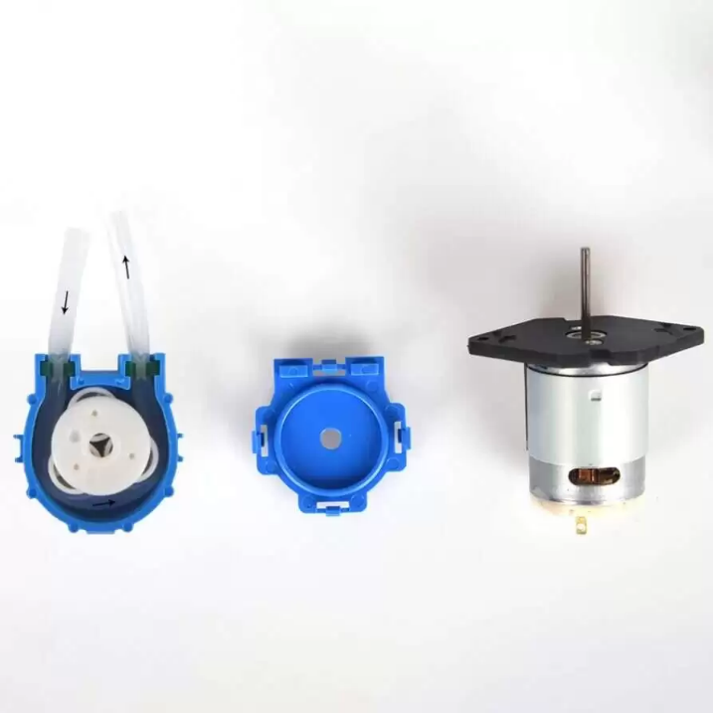

Figure 2 illustrates the peristaltic pump inner parts and mechanism.

A HDPE disk, a material with a density close to water, is positioned to divide the cylinder into two sections. The upper section houses the electrical components, while the lower section serves as a water chamber for density control. The disk features grooves to mount O-rings, ensuring secure isolation between the two sections. Additionally, chemical sealing agents such as epoxy are used to reinforce the isolation. The suction system uses two peristaltic pumps for suction and ejection, operating at a flow rate of 60 ml/min, allowing the 700 ml chamber to be filled or emptied in approximately six minutes per operation. These pumps function by compressing a flexible tube with rotating rollers, generating a wave-like motion that pushes fluid through the tube, allowing precise flow control. To prevent leakage, the inlet and outlet hoses pass through PG-9 glands using 8 mm pneumatic hose.

The float is sealed at both ends using custom end caps, each consisting of four stacked layers of HDPE. The outermost layer is 5 mm thick and exposed to water, while the remaining three layers are 10 mm thick and feature grooves designed to accommodate three O-rings for secure sealing. These layers are fastened together using bolts and nuts to ensure structural integrity and leak-proof performance. The end caps are friction-fit into the housing and are not secured with other fastening methods.

2. Electrical and Communication systems